DIVING STATUS UNDERWATER SERVICES

SERVICE REPORT



Vessel: | HELLAS ATHINA
Scope of Services: | Damage Report
Date: | 20th to 24th August 2023
Place: | Panama
Ref. No.: | DS-23-4535

Date: 25/08/2023
To: LATSKO
Att: Mr. Elias Karystios

Service Summary
Preface | : | On 20/08/23 until 24/08/23 our team of specialty welding divers with necessary equipment was mobilized to subject vessel.  Upon arrival at the vessel, our representative liaised with the Master and Chief Engineer onboard to ensure availability and safe access to the work area.
Scope of Services | : | Damage Report
 |  | Please refer to following report.

Vessel Details
Name | : | HELLAS ATHINA
IMO | : | 9872999
Class | : | ABS
Date | : | 20.08.23 – 24.08.23
Place | : | Panama

Operational Details

Team’s departure from Athens | : | August 19th
Team’s arrival at Panama | : | August 19th (due to time zone difference)
Date of operation | : | August 20th - August 24th
Team’s departure from Panama | : | August 24th
Team’s arrival to Athens | : | August 26th (due to time zone difference)

DAILY SUMMARY REPORT FROM OUR SUPERVISOR TEAM ONBOARD

Date: 19.08.2023
Our team arrived at your good vessel LNG Tanker Hellas Athina.

Date: 20.08.2023
Second day in the morning, our team started with consulting; they went to the local divers, who are on board in order to examine with them the material from the damaged area (photographs & videos). Together they discussed, how they will procced with the repairs and our supervisors watched through CCTV the repairs that local divers carried out the specific moment and to check if plastic steel had any leakage.
After that, our team took the material and went to discuss with your superintendent engineer, Mr. Alexios Pippos in order to discuss with him our proposal regarding the repair plan from our side.
Until the night our team was stand by, because they waited the water pumps to empty the Bob Room. When finally, Bob room was empty, our team went down in order to monitor from inside the damage area and the specific place and where there is leakage. They found the exact area and they suggested putting quick-drying cement.

Date: 21.08.2023
Third day, our team went down inside the vessel’s ballast tanks, to check and record the situation from Frame 117 until Frame 192. They took photographs & videos from the damaged areas, port and starboard side. Ballast tanks had on about 50cm water, for this reason our team was stand by and waited fore peak to be empty from water. After that our team proceeded with the video recording, photographs and the detailed mapping of the damaged area. They measured all the damaged area to calculate the quantity of iron sheet that the vessel will need for the repairs.
After completion of this task our team discussed with the supervisor from the local divers’ team, the repair plan for the next days and they took photographs and videos from the repairs that they have complete until 21.08.23.

Date: 22.08.2023
Fourth day our team discussed with Mr. Pippos, how they will proceed with mapping of the rest damaged area. They started with mapping from fore-port area the Frame 117 until Frame 91. After completion of this area, they went at aft-starboard area at the vessel and they mapped same frames, 117 – 91. Finally, they mapped the pump room from Frame 117 until 125.
Our team was stand by in order fore peak department to be drained from water by the water pumps, in order to successful complete the mapping at this area.

Date: 23.08.2023
Fifth day our team informed Mr. Pippos for the damages that they had mapped until this moment & they discussed how they will proceed.
Our team was stand by also this morning because fore peak was not empty yet. When fore peak was finally drained by water, team proceed with mapping from the Frame 125 until Frame 138.

Date: 24.08.2023
Sixth day our team went to fore peak in order to finish properly the mapping at this damaged area. The echosounder sensor & speed log sensor boxes were underneath the water and not empty yet.

HELLAS ATHINA IMO:9872999
DAMAGE REPORT
Summary

After all the inspection that conducted the total estimated area of the damage is between Frame 95 to Frame 137 ,with multiple indentations and fractions observed in the vessel’s hull. Below you can see the further details about the total damage. (Drawing 1, Drawing 2, Drawing 3, Drawing 4, Drawing 5, Drawing 6).

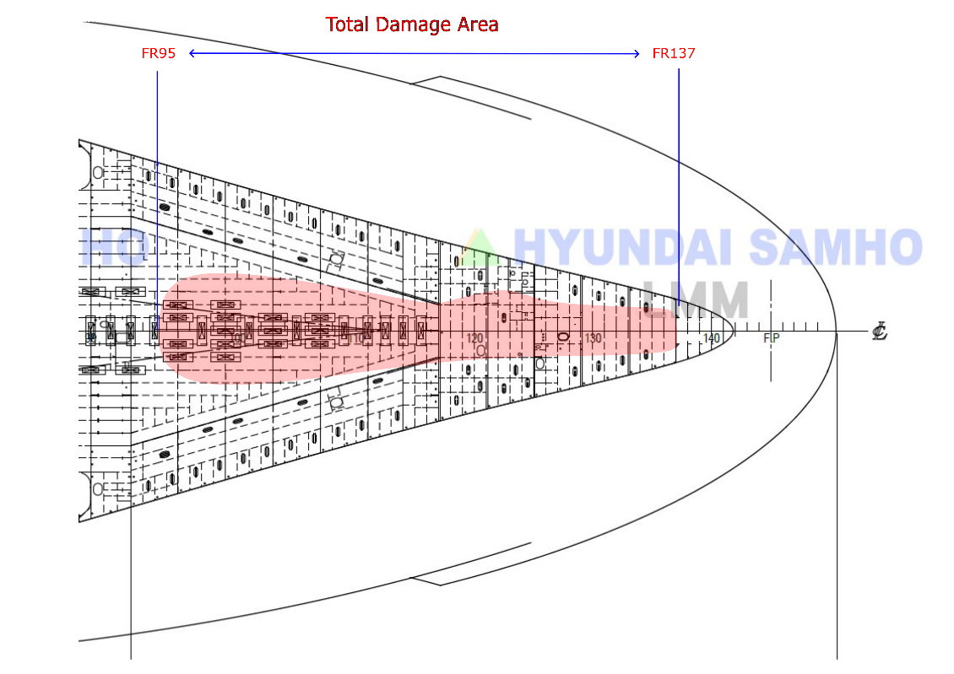
Drawing 1 : Total Damage Area estimated by Diving Status.

Our team of specialty divers was always in supervision and communication with owner’s representative , Superintendent Engineer Mr. Alexios Pippos.
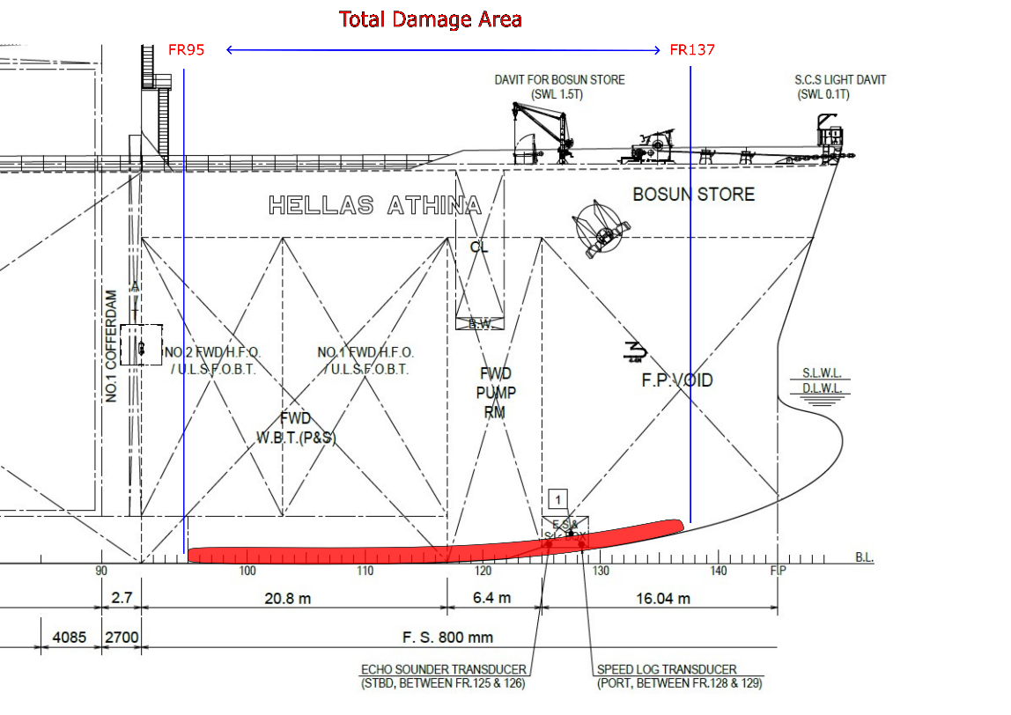
Drawing 2 : Total Damage Area estimated by Diving Status.

Please notice that all the recording of the damaged area that conducted from outside the vessel (underwater) was delivered to our team by the Talleres Industriales S.A with the form of Photographs and Videos. All this material inspected by our team onboard and onshore thoroughly in order to achieve the best possible results.

After the assessment of the damaged areas we recommend the below:

- Cut all the unnecessary pieces of the damaged area in order to even the surface of the platting.
- Drilling of stopping holes of diameter 20mm – 30mm at the end of both sides of the cracks.
- Doubler platting via welding method.
- Epoxy Putty appliance after the new welding.

When the above steps complete properly, these temporary repairs they will allow the vessel to sail in the next port for further maintenance.

Page 1 – Fore Peak 1
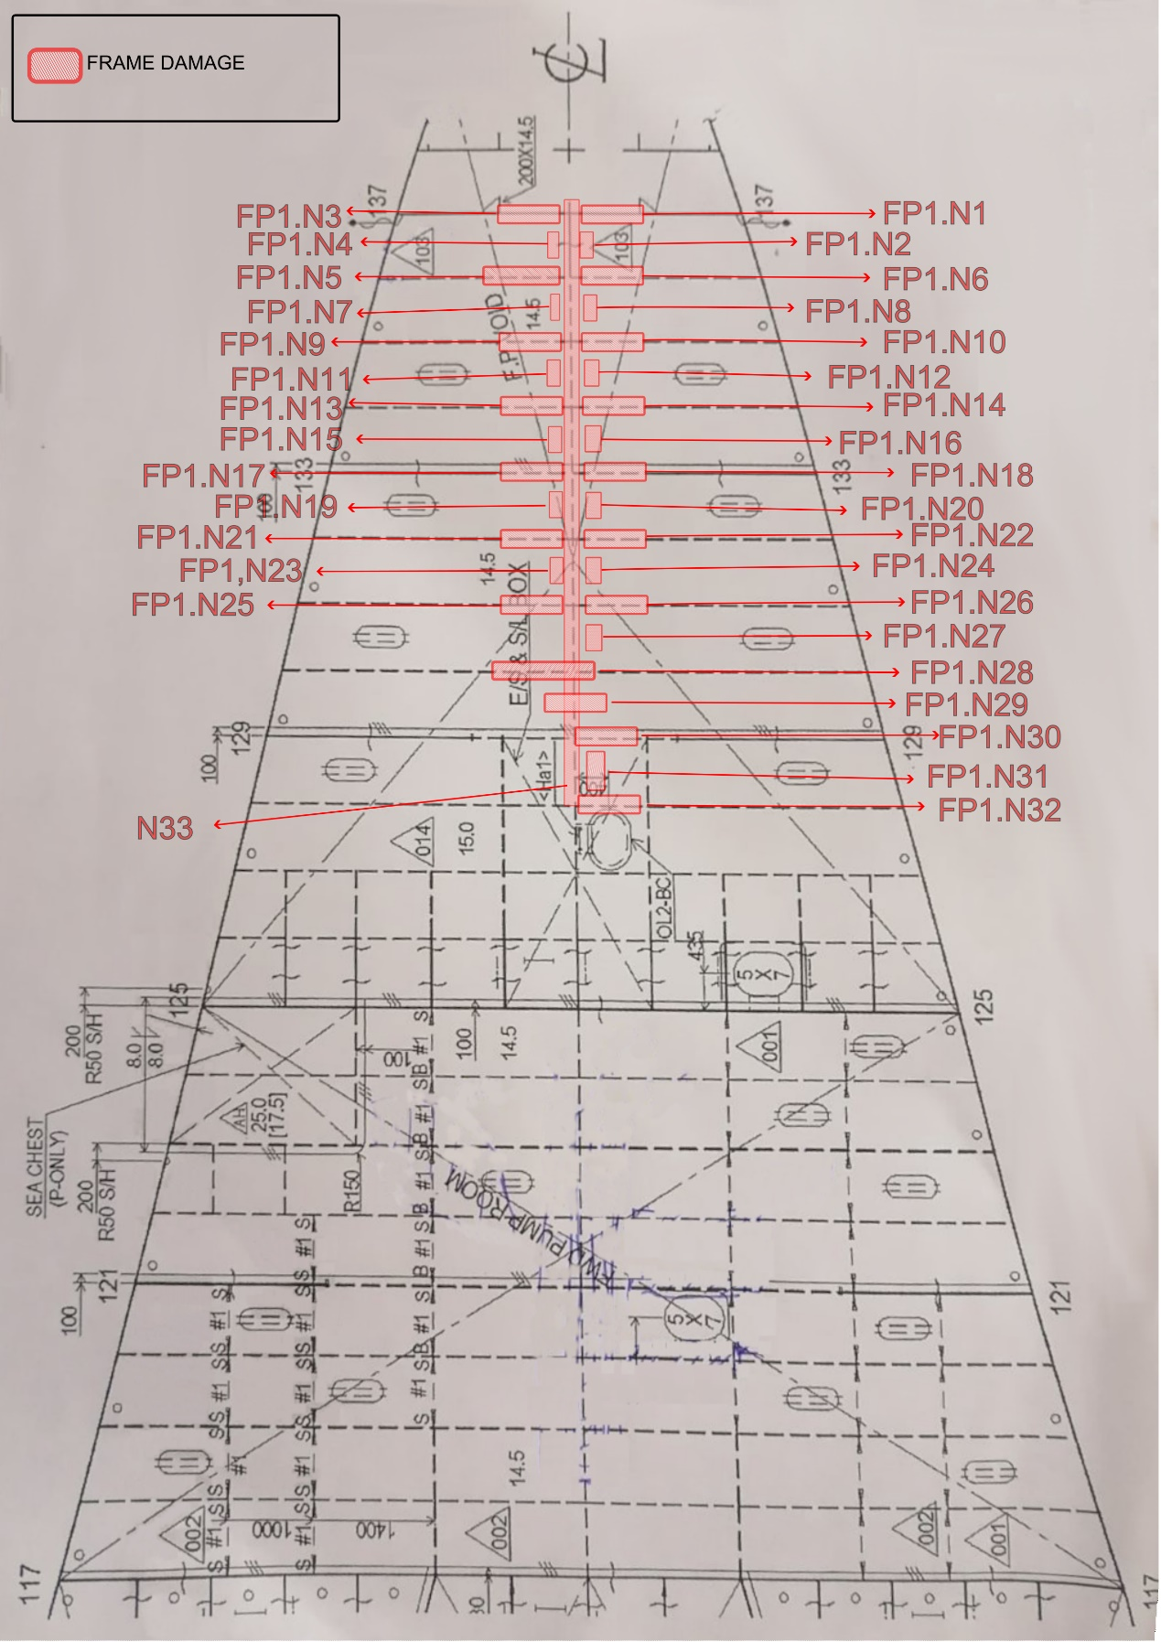
Drawing 3 : Fore Peak 1 Section Damage Report – Frame 125 – Frame 137

Page 1 – Fore Peak 1
FP1.Ν1: Frame No.137 indentation with wrinkle, dimensions 0.35m length X 0.70m width.

FP1.Ν2: From frame No.137 to frame No.136 upwards indentation with dimensions 0.80m length X 0.50m width.

FP1.Ν3: Frame No.137 indentation with wrinkle, dimensions 0.40m length X 0.70m width.

FP1.Ν4: From frame No.137 to frame No.136 upwards indentation with dimensions 0.80m length X 0.20m width.

FP1.N5: Frame No.136 indentation with wrinkle, dimensions 0.80m length X 0.70m width.

FP1.N6: Frame No.136 indentation with wrinkle, dimensions 0.35m length X 0.70m width.

FP1.N7: From frame No.136 to frame No.135 upwards indentation with dimensions 0.80m length X 0.20m width.

FP1.N8: From frame No.136 to frame No.135 upwards indentation with dimensions 0.80m length X 0.50m width.

FP1.N9: Frame No.135 indentation with wrinkle, dimensions 0.70m length X 0.80m width.

FP1.N10: Frame No.135 indentation with wrinkle, dimensions 0.40m length X 0.80m width.

FP1.N11: From frame No.135 to frame No.134 upwards indentation with dimensions 0.80m length X 0.20m width.

FP1.N12: From frame No.135 to frame No.134 upwards indentation with dimensions 0.80m length X 0.50m width.

FP1.N13: Frame No.134 indentation with wrinkle, dimensions 0.40m length X 0.30m width.

FP1.N14: Frame No.134 indentation with wrinkle, dimensions 0.50m length X 0.70m width.

FP1.N15: From frame No.134 to frame No.133 upwards indentation with dimensions 0.80m length X 0.20m width.

FP1.N16: From frame No.134 to frame No.133 upwards indentation with dimensions 0.80m length X 0.50m width.

FP1.N17: Frame No.133 indentation with wrinkle, dimensions 0.40m length X 0.90m width.

FP1.N18: Frame No.133 indentation with wrinkle, dimensions 0.40m length X 0.90m width.

FP1.N19: From frame No.133 to frame No.132 upwards indentation with dimensions 0.80m length X 0.20m width.

FP1.N20: From frame No.133 to frame No.132 upwards indentation with dimensions 0.80m length X 0.50m width.

FP1.N21: Frame No.132 indentation with wrinkle, dimensions 0.50m length X 1.00m width.

FP1.N22: Frame No.132 indentation with wrinkle, dimensions 0.50m length X 1.00m width.

FP1.N23: From frame No.132 to frame No.131 upwards indentation with dimensions 0.80m length X 0.20m width.

FP1.N24: From frame No.132 to frame No.131 upwards indentation with dimensions 0.80m length X 0.50m width.

FP1.N25: Frame No.131 indentation with wrinkle, dimensions 0.50m length X 1.00m width.

FP1.N26: Frame No.131 indentation with wrinkle, dimensions 0.50m length X 1.00m width.

FP1.N27: From frame No.131 to frame No.130 upwards indentation with dimensions 0.90m length X 0.60m width.

FP1.N28: Frame No.130 indentation with wrinkle, dimensions 3.00m length X 1.00m width.

FP1.N29: From frame No.130 to frame No.129 upwards indentation with dimensions 2.00m length X 0.70m width.

FP1.N30: Frame No.129 indentation with wrinkle, dimensions 1.20m length X 0.60m width.

FP1.N31: From frame No.129 to frame No.128 indentation with fracture with dimensions 1.00m length X 0.40m width.

FP1.N32: Frame No.128 indentation with wrinkle, dimensions 1.00m length X 0.60m width.

Page 2 – Fore Peak 2

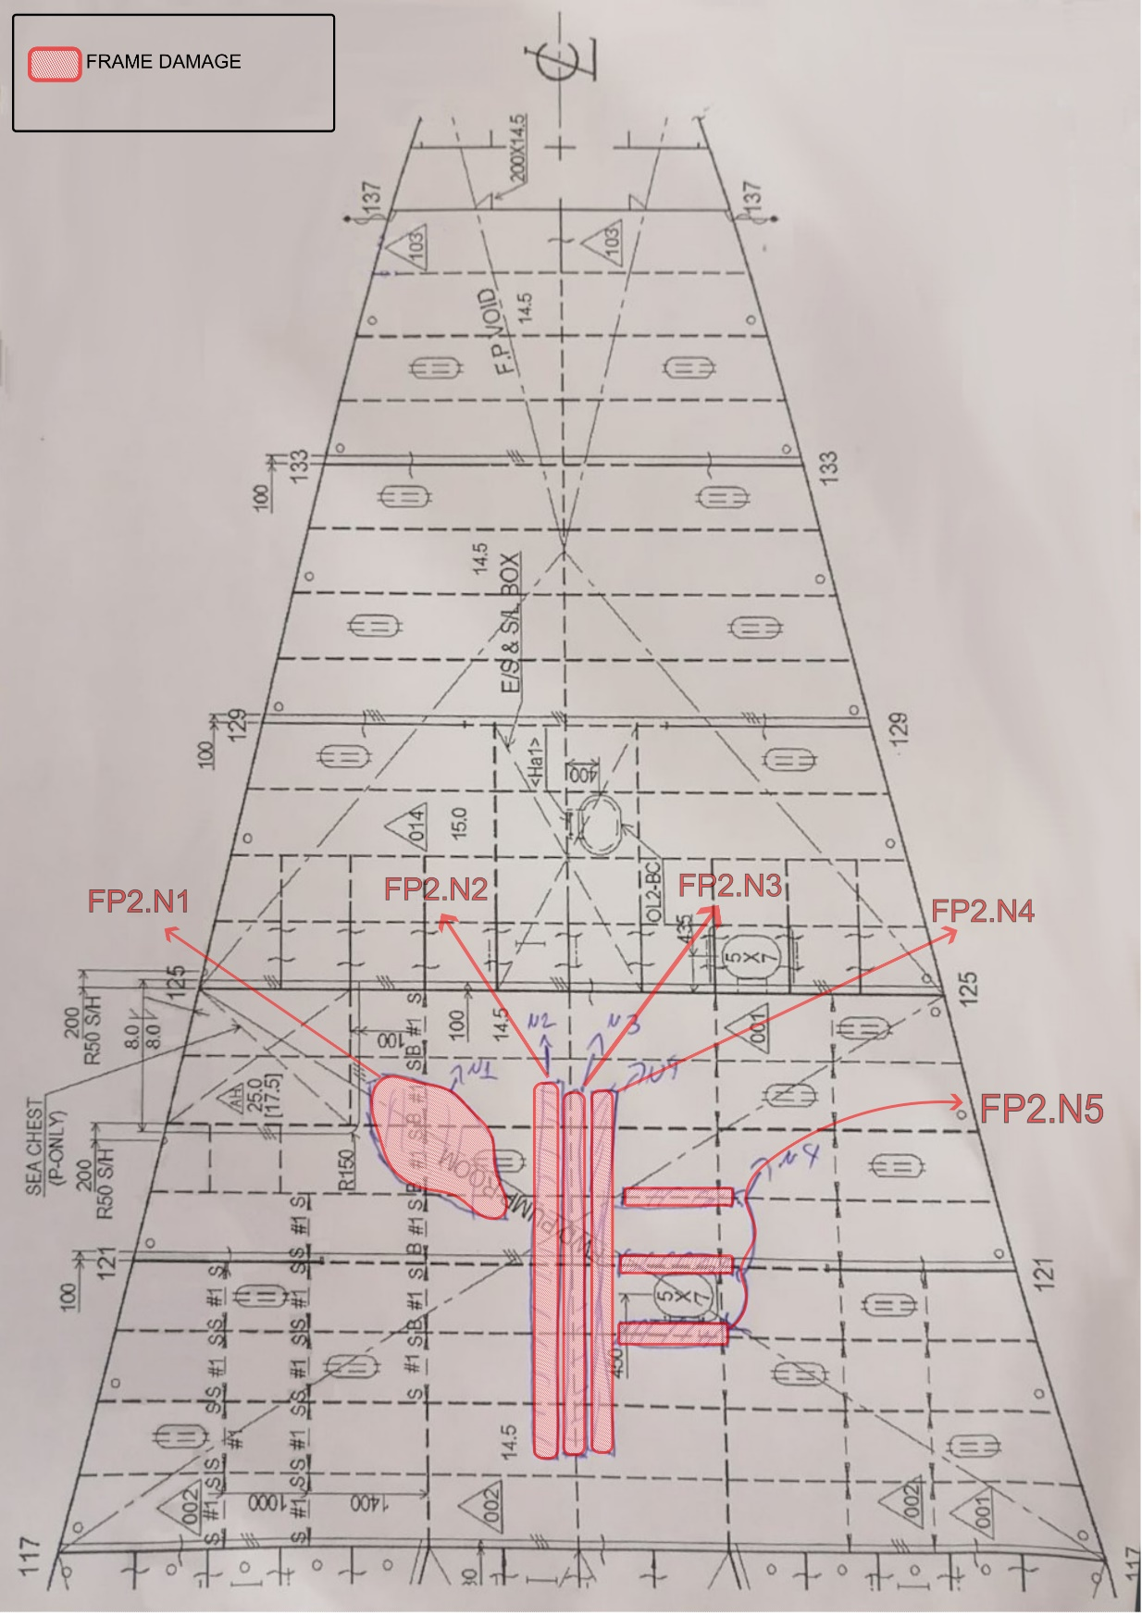
Drawing 4 : Fore Peak 2 Section Damage Report Frame 117 – Frame 125

Page 2 – Fore Peak 2

FP2.N1: From frame No.122 to frame No.129 upwards indentation with dimensions 2.00m length X 1.50m width.

FP2.N2: From frame No.129 to No.118 upwards indentation with dimensions 4.80m length X 0.60m width.

FP2.N3: Central line bulkhead from frame No.118 to No.124 indentation with wrinkle, dimensions 5.00m length x 0.90m width.

FP2.N4: From frame No.124 to No.118 upwards indentation with dimensions 9.80m length X 0.60m width.

FP2.N5: Frame No.120, frame No.121 and frame No. 122 indentation with wrinkle, dimensions 2.00m length X 0.80m width.

Page 3 - Port Side

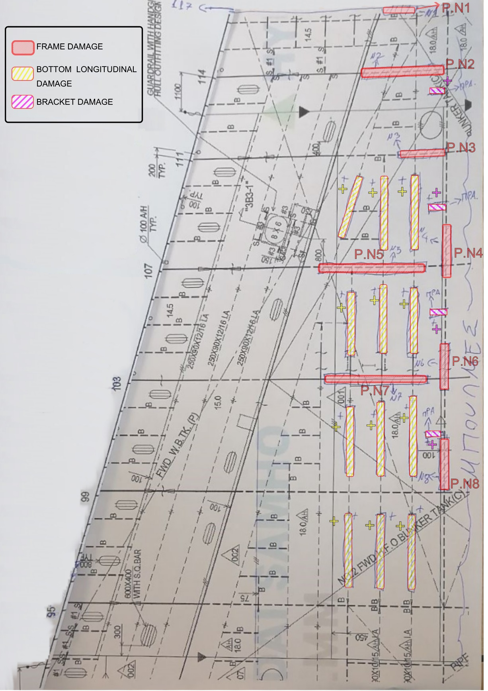
Drawing 5 : Port Side Section Damage Report - Frame 95 – Frame 117

Page 3 - Port Side

P.N1: Frame No.117 indentation with wrinkle, dimensions 0.70m length X 0.40m width.

P.N2: Frame No.114 indentation with wrinkle, dimensions 1.65m length X 0.90m width.
+1 bracket with distortion

P.N3: Frame No.111 indentation with wrinkle, dimensions 1.00m length X 0.45m width.
+3 bottom longitudinal with distortion
+1 bracket with distortion

P.N4: From frame No.107 to No.109 indentation with dimensions 1.90m length X 0.40m width.

P.N5: Frame No.107 indentation with wrinkle, dimensions 3.40m length X 0.60m width.
+3 bottom longitudinal with distortion
+1 bracket with distortion

P.N6: Main bulkhead from frame No.103 to frame No.105 indentation with crack, dimensions 2.40m length X 1.50m width.

P.Ν7: Frame No.103 indentation with wrinkle, dimensions 3.70m length X 1.30m width.
+3 bottom longitudinal with distortion
+1 bracket with distortion

P.N8: Main bulkhead from frame No.99 to No.102 indentation with dimensions 3.00m length X 0.80m height.
+3 bottom longitudinal with distortion

Page 4 - Starboard Side

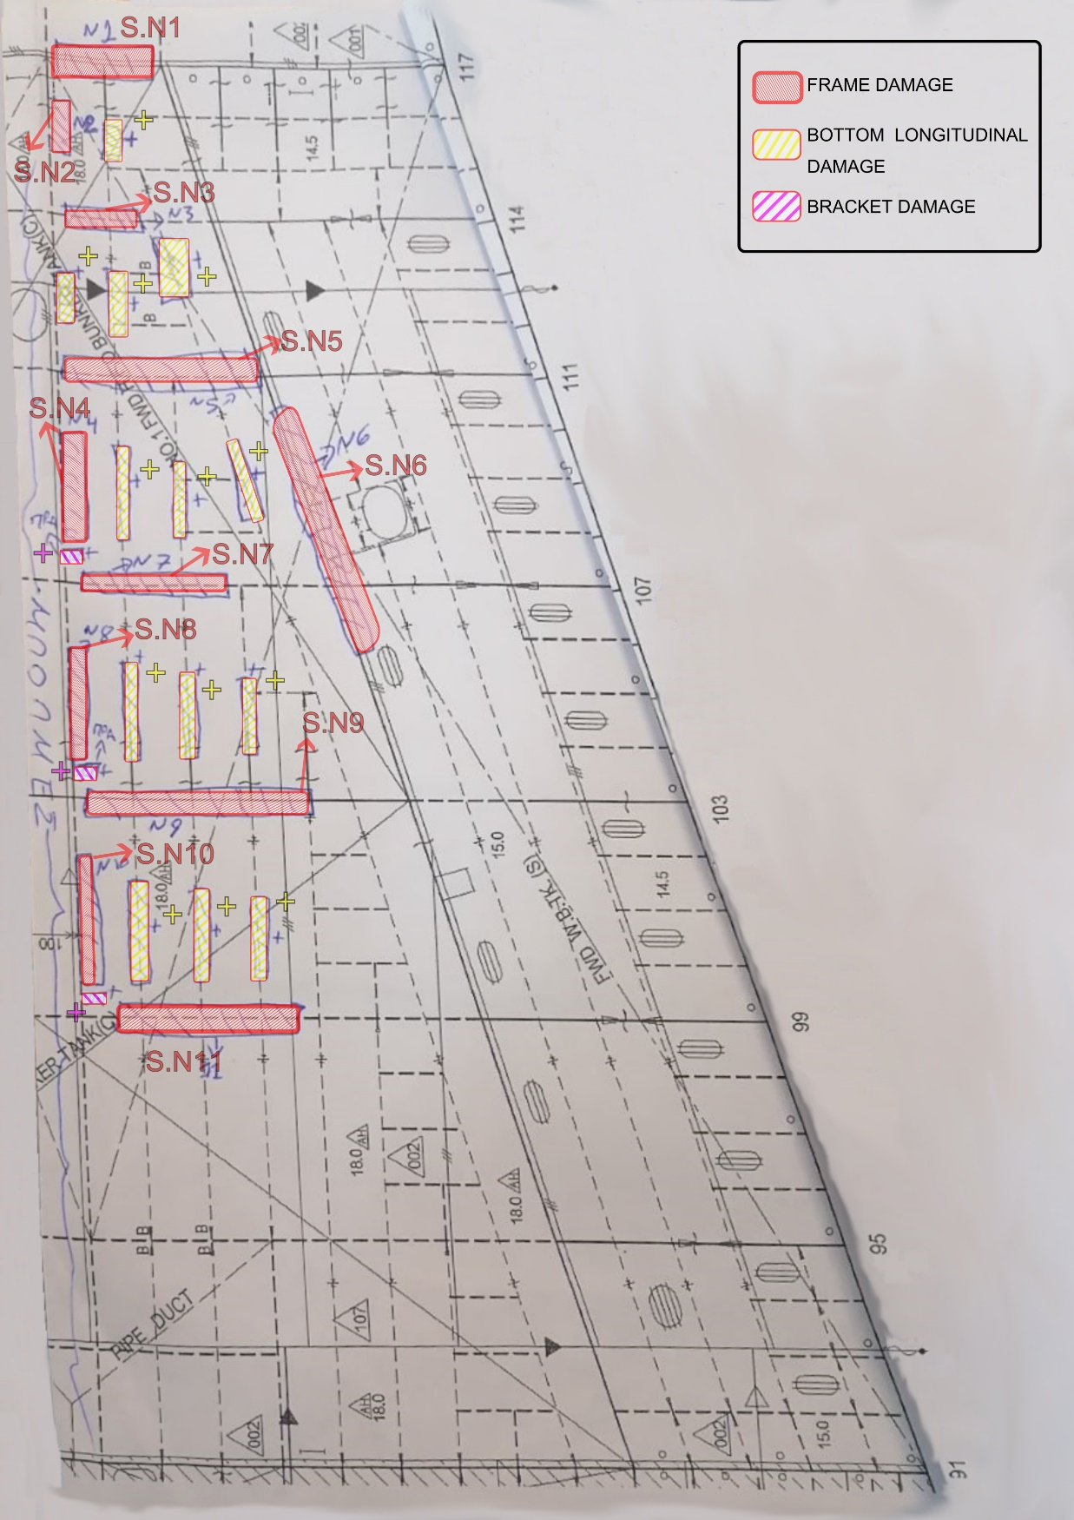
Drawing 6 : Starboard Side Section Damage Report - Frame 95 – Frame 117

Page 4 - Starboard Side

S.N1: Frame No.117 indentation with dimensions 1.70m length X 0.30m width.

S.N2: Central line bulkhead from frame No.114 to No.116 indentation with dimensions 0.60m length X 0.30m width.
+3 bottom longitudinal with distortion

S.N3: Frame No.119 indentation with dimensions 1.00m length X 1.10m width.
+3 bottom longitudinal with distortion

S.N4: Main bulkhead from frame No.108 to No.109 indentation with dimensions 2.50m length X 0.80m width.
+3 bottom longitudinal with distortion

S.N5: Frame No.111 indentation with dimensions 3.00m length X 0.40m width.

S.N6: Bulkhead From frame No.105 to No.111 indentation with dimensions 8.50m length X 0.60m width.
+1 bracket with distortion

S.N7: Frame No.107 indentation with dimensions 3.50m length X 1.10m width.

S.N8: Main bulkhead from frame No.104 to No.106 indentation with dimensions 3.00m length X 0.80m width.
+3 bottom longitudinal with distortion
+1 bracket with distortion

S.N9: Frame No.103 indentation with dimensions 5.00m length X 1.00m width.

S.N10: Central line bulkhead from frame No.100 to No.103 indentation with dimensions 3.00m length X 0.80m width.
+3 bottom longitudinal with distortion
+1 bracket with distortion

S.N11: Frame No.99 indentation with dimensions 4.00m length X 0.70m width.

PHOTOGRAPHIC APENDIX

